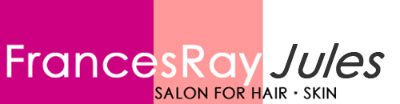

Salon Specials

1st Time Client Color Special
FREE Haircut with any full priced color service including
Partial Highlight, Full Highlight, Free Hand Painting & Single Process
(Up to $95 value)
Select stylist only

1st Time Client Haircut Special
Men’s Haircut $25
Woman’s Haircut $45
Not valid with Creative Director
Select stylist only

1st Timer Express Blowout Savings
Keratin Express Blowout reduces frizz, debulks and reduces drying time.
$100.00 (Up to $225 value)
Select stylist only

Lengthen Your Summer Locks!
All extension services 30% OFF.
Choose between Clip-In, Poly Bond, and Tape-In Extensions
Select Stylist Only

Packages must be used in one visit. Specials cannot be combined with any other offer or coupon.
Offers end September 30th

